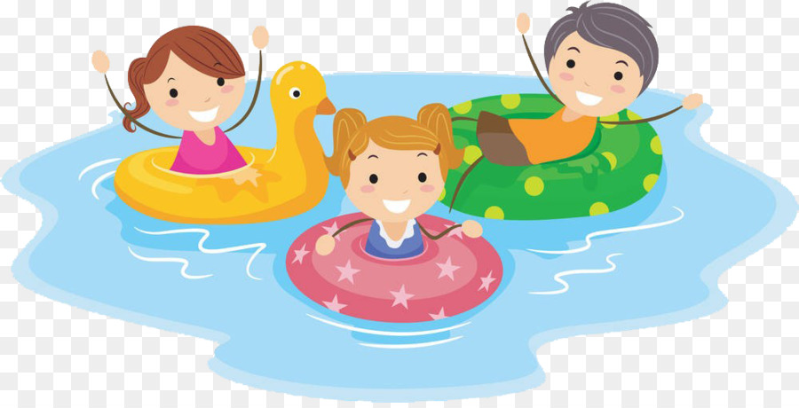
Parent & Toddler Sessions
Want to give your toddler or baby some water confidence in the big pool at a special price of £4 for parent + toddler. Water temperature is approx. 29 degrees and we have changing facilities and even sell swim nappies.
During this session there will also be a lane for adults to swim in too.
Watch our Facebook page for more dates in the school holidays (-5’s only though for these sessions, sorry)

